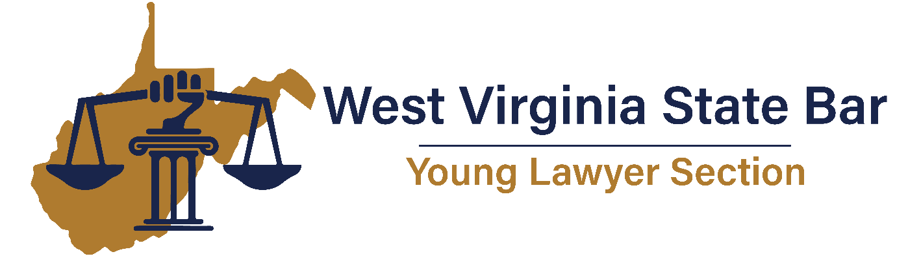
BRIDGE THE GAP PROGRAM
Embassy Suites
Charleston, West Virginia
April 8, 2024

7:30 a.m. – 8:30 a.m. Check-In
8:30 a.m. – 9:00 a.m. Welcome to West Virginia State Bar: Services Offered by the Bar – Mary Jane Pickens, Executive Director, West Virginia State Bar
9:00 a.m. – 9:50 a.m. Culture Shift: Tools for Sustainability in Legal Practice– Stephanne Thornton, Clinical Director for the West Virginia Judicial & Lawyer Assistance Program
9:50 a.m. – 10:40 a.m. Pro Bono in WV: Opportunities, Benefits, and Resources to Help – Katie White, Esq., Legal Aid of West Virginia
10:40 a.m. – 11:30 a.m. Federal v. State Court Civil Practice – Honorable Michael Aloi & Honorable Omar Aboulhosn, Federal Magistrate Judges
11:30 a.m. – 12:30 p.m. Lunch
12:30 p.m. – 1:20 p.m. Civility Matters – Rob Aliff, Esq., Secretary/Treasurer, American Board of Trial Advocates, West Virginia Chapter
1:30 p.m. – 2:20 p.m. Plight of the Everyday Young Lawyer: Work/Life Balance – Bonnie Thomas, Esq., Ashton Bias, Esq., John Isner, Esq., Sophia Mills, Esq. – Moderated by Lindsey McIntosh, Esq.
2:30 p.m. – 3:00 p.m. Puppy Break
3:00 p.m. – 3:50 p.m. The Attorney’s Duty to the Court and Counsel – What Circuit Court Judges expect of new lawyers – Honorable Joseph Reeder, Putnam Circuit Court Judge
4:00 p.m. – 4:50 p.m. Legal Ethics: How to avoid the Office of Disciplinary Counsel and what to do if you have a complaint – Rachael Cipoletti, Esq.

